Portfolio assignment ethics 2 Reinder Weenink

1. Breeze has developed an algorithm which suggests profiles to users. If both users like the other person, they form a match and go dating. The algorithm computes the chance a user likes other users and proposes profiles to the user based on this chance. The algorithm is autonomous in learning. It continually tries to improve itself based on the information found on the user profiles and the “liking” behaviour, without human intervention. Some users of the platform complain about the variance in the suggested profiles. Breeze thinks that users with another ethnic background cancel the subscription because they have few matches. Breeze reasons that the algorithm therefore computes a lower matching chance for users of other colour and or ethnicity. It can be the case that Breeze is trained on a database which is not balanced for people of other ethnicity and or colour. That will give the favoured group an unbalanced matching chance. The algorithm is continuously retrained to perform better, if the imbalance is strengthened by leaving people of other ethnicities and colour the algorithm will lower chances even more for this group.
2. Dag

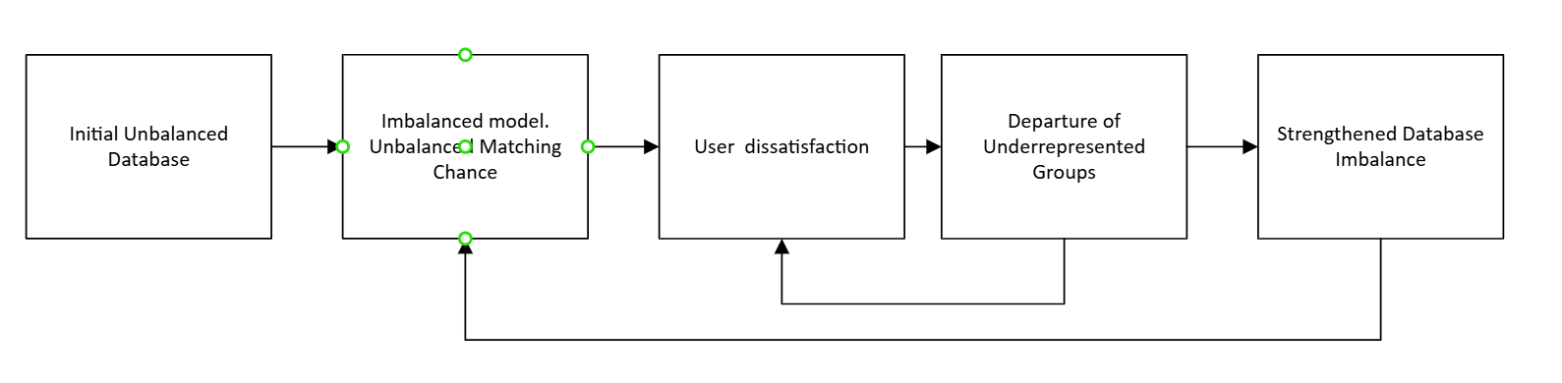

1. Drawing the DAG gave me a better overview of the problem. It is easier to view the problem from a broader perspective in this manner. I did not see first that there are actually two feedback circles. If people are dissatisfied, then they will leave and the user base directly is impacted by this. Training will probably not be real time and so the model is at first less impacted by people leaving, so there is a delay in the database imbalance and the model imbalance. I must admit that my first opinion on the model being discriminative must be altered. I can also be the case that people themselves are discriminative and therefore the model is as well. So maybe people just like to be confronted with people who look not too different than themselves. On the other hand, this could have been researched as well and addressed before launch.
2. When there is a chance to build a model which can be discriminative, in my opinion it is important to make sure that the model is understandable and can be corrected if it drifts in a direction which is discriminative. Business-wise this is also important, because you want to reach as many people as possible.